**Practical 1**

**Title:** Creating account on github, creating repository and cloning repository in Github page.

**CREATING ACCOUNT ON GITHUB**

1. Search on google chrome **GitHub.com**
2. Click on sign up (If your account is already created then click on sign in).

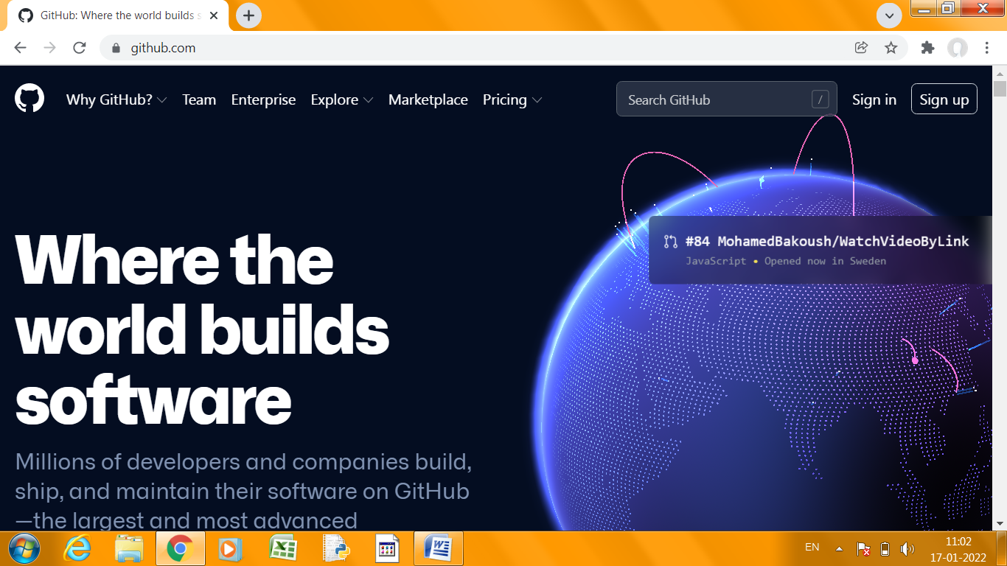

1. Enter your Email, password and username.
2. After that click on Start puzzle.
3. After selecting puzzle click on continue and then you will get a code on your Email id and enter the respective code.
4. After creating your account go to repository and click on new.

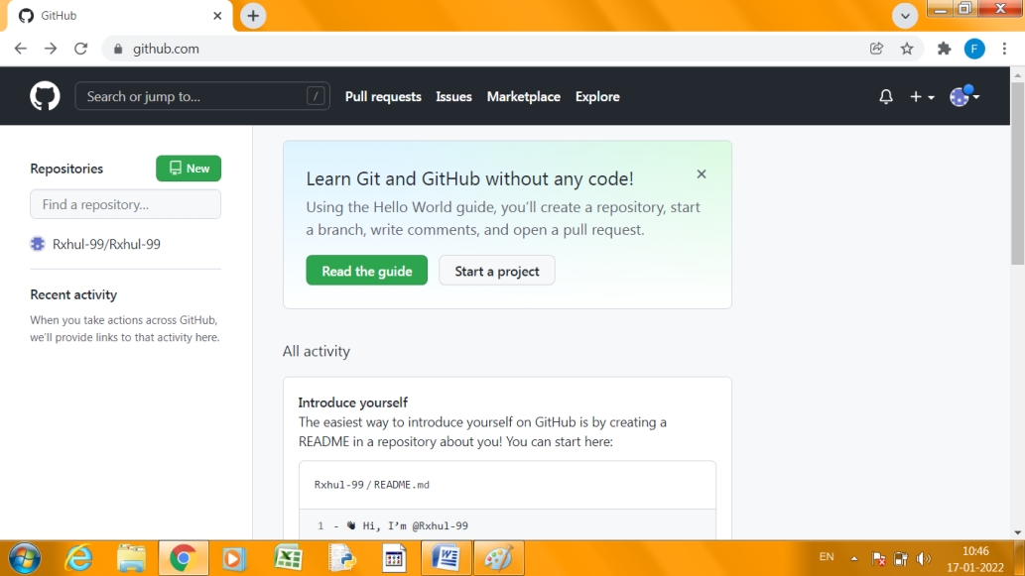

1. Create a repository name and click on create repository.

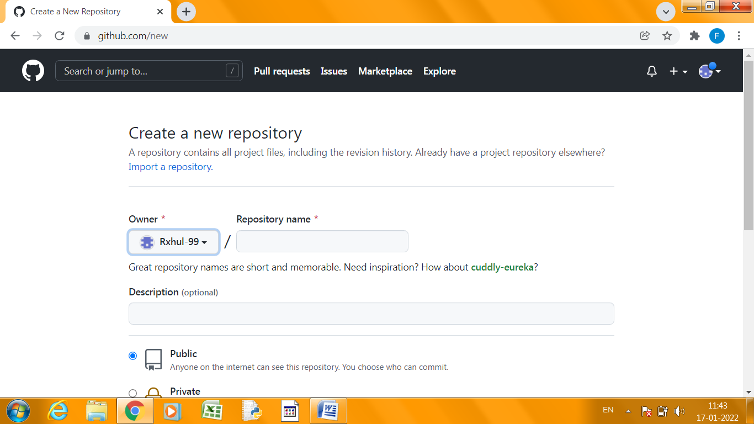

1. Cloning the repository.

For cloning the repository just copy paste link which is present on the git hub page.